OLYMP-I-A CHALLENGE
ACTION PACKET
FOR: PRINCIPALS, TEACHERS, YOUTH GROUP LEADERS & VOLUNTEERS
CHANGEMAKER SCHOOLS

Contents:
**Introduction, Instructions, and Tips
**Sample Achievement Certificates
**Label Formats to Create Olymp-i-a Challenge Journal Labels

Key Steps:
1. Learn more about the Olymp-i-a Challenge and help involve children and youth. Read the enclosed information and instructions.
2. Take the Olymp-i-a Challenge yourself. Write in your journal. Be a positive leader and changemaker for peace, green-living, and health.
3. Encourage someone else to take the Challenge with you. Support each other and have fun!
OLYMP-I-A CHALLENGE INSTRUCTIONS FOR: CHANGEMAKER SCHOOLS
Introduction to the Olymp-i-a Challenge for Changemaker Schools, principals, teachers, volunteers, and interested participants:
The Olymp-i-a Challenge is a simple, fun 10-15 minute activity (practiced daily over a 2-4 week period) that helps children and youth [and adults] strengthen essential life skills and become champions for peace, green-living, and health.
The "i" and "a" in "Olymp-i-a" stand for positive "ideas" and "actions" for peace, green-living, and health. When children and youth practice positive ideas and actions in these 3 areas, they develop empathy for self, others, and the Earth. The Challenge supports the principles of Ashoka Changemaker Schools. It is critical that children and youth recognize their roles as active contributors to peace, green-living, and health; practice and strengthen positive choices based on empathy; and understand that their daily simple steps do make a difference.
To do the Challenge, children and youth go on a daily "treasure hunt" for peace, green-living and health and write (or draw for young children) about what they discover. With daily journaling of their own discovered ideas and actions for peace, green-living, and health, children translate these universal global goals into their own daily reality and culture. They increase awareness and internalize positive habits. They practice and strengthen positive life skills in these areas and exercise empathy. As a bonus, they practice creative writing/expression skills (drawing for young children) and immediately see themselves as the changemakers they are.
Changemaker Schools may choose to start the Challenge with a small group of children/youth or with an entire class or school. Group leaders /teachers/youth mentors may be creative in their approach to encourage and support the basic Olymp-i-a Challenge "treasure hunt" and journaling technique.
(OVER)

Changemaker Schools are in an ideal position to serve as models for other schools and youth groups. The Challenge has great potential for positive impact and is easy for teachers and youth group leaders to use to support their current activities.
Lesa R. Walker, MD, MPH is the originator of the Olymp-i-a Challenge. She has developed basic instructions (enclosed in this packet) to facilitate doing the Challenge with children/youth at the group, class, and school levels. These instructions are also helpful to orient adults to do the Challenge. Additional resources are available on her website http://www.idea4idea.com/ (specifically the "Children and Youth" page at http://www.idea4idea.com/id125.html).
We want children and youth to be the change they want to see in the world. This is your opportunity to take 10-15 minutes/ day and launch children and youth [and yourself] on a brilliant path of discovery for peace, green-living, and health. When we create positive change in these 3 areas, we make the world a better place.

OLYMP-I-A CHALLENGE INSTRUCTIONS FOR: CHANGEMAKER SCHOOLS
Olymp-i-a Challenge: For Children (Ages 3-8)

Instructions for the Group Leader

1. Tell the children about the “Olymp-i-a” Game (see below) and set aside a time every day for them to write or draw. Make it a routine! Stay positive and excited. 2. Tell the children the number of days they will do the Game (ideally at least 21 days but you can start with less).
3. You may want to do the challenge yourself!
4. Use the “Tips for Explanation” and the “Daily Motivation Questions and Action Prompts” to get started and to help keep the children engaged.
5. You may want to use the challenge to support a project you are doing with the children that relates to peace, green-living, or health (e.g. have the children write or draw about something they learned or did that day as part of the project and think about how it applies to their everyday lives).
6. Each child uses paper or a notebook or journal (you can make a notebook by binding/stapling papers together) for their positive ideas and actions.
7. Be VERY interested in what they write and draw each day- ask them about it. You may want to talk about various ideas and actions. You may want to give suggestions of positive ideas or actions, good books for them to read, educational resources, etc.
8. Help them make the simple connection between what they think and do during the day and how that relates to health, green-living, and peace. Make each day a fun “treasure hunt” of discovery.
9. You may want to recognize the children for generating their positive idea or action for the day. You can make a chart (a chart listing the children in your class/group and the days of the challenge) and put a checkmark for each day a child writes or draws about a positive idea or action. (OVER)

The Way It Works

1. Children write down or draw about at least ONE positive idea or action each day about what they think or do to be healthy, help the earth, or help others.

2. They get encouragement and support each day to do it.

3. They can write down more than one idea or action in a day if they want. The goal is to write down or draw about at least one positive idea or action each day for as many days as possible in the time period of the game.

4. If they miss a day, that’s no problem. They are encouraged to continue. The more days they can do, the better, even if they miss a day or days here and there.

5. They can write the same idea or action again on more than one day. If you notice this, encourage them to think/do different things and you may want to review some examples with them (use the “Tips for Explanation” and the “Daily Motivation Questions and Action Prompts”). However, be sure to accept, acknowledge, and support anything positive they write/draw.

6. The ideas and actions must be POSITIVE (express what is, or can be, in positive words, not dwell on what is wrong).

7. If a child writes something that indicates they are missing the point of the game, help them by explaining to them what it is they should be doing. Give examples (use the “Tips for Explanation” and the “Daily Motivation Questions and Action Prompts”).

8. At the end of the time period for the game, tally up how many days the children generated positive ideas and actions for health, green-living, and peace. Tally up how many ideas and actions they generated. Read some of them to the children. Celebrate the importance of what they have done. Encourage them to keep going.

OLYMP-I-A CHALLENGE INSTRUCTIONS FOR: CHANGEMAKER SCHOOLS
Olymp-i-a Challenge: For Youth (Ages 8 thru Teens)

Instructions for the Group Leader

1. Tell the youth about the “Olymp-i-a” journaling challenge (see below) and set aside a time every day for them to journal. Make it a routine! Stay positive and excited.
2. Tell the youth the number of days they will do the challenge (ideally at least 21 days but you can start with less).
3. You may want to do the challenge yourself!
4. Use the “Tips for Explanation” and the “Daily Motivation Questions and Action Prompts” to get started and to help keep the youth engaged.
5. You may want to use the challenge to support a project you are doing that relates to peace, green-living, or health (e.g. have the youth journal about something they learned or did that day as part of the project and apply it to their everyday lives).
6. Each youth uses paper or a notebook or journal (you can make a notebook by binding/stapling papers together) for their positive ideas and actions.
7. Be VERY interested in what they write and draw each day- ask them about it. You may want to talk about various ideas and actions. You may want to give suggestions of positive ideas or actions, good books for them to read, educational resources, etc.
8. Help them make the simple connection between what they think and do during the day and how that relates to health, green-living, and peace. Make each day a fun “treasure hunt” of discovery.
9. You may want to acknowledge that a youth has generated a positive idea or action for the day. You can make a chart (a chart listing the youth in your Group and the days of the challenge) and put a checkmark for each day a youth writes or draws about a positive idea or action. (OVER)

The Way It Works
1. Youth journal (write down or draw) at least ONE positive idea or action each day about what they think or do for health, green-living, or peace. What they write/draw can be very simple or complex. They can do artwork or write poetry. They may describe a simple action or something they do as part of a more complex project.
2. They get lots of encouragement each day to do this.
3. They can write down more than one idea or action in a day if they want.
4. The goal is to do this journaling for as many DAYS as possible in the time period of the OLYMP-I-A journaling challenge. The message is that practice makes us stronger.
5. If they miss a day, that’s no problem. They are encouraged to continue. The more days they do, the better, even if they miss a day or days here and there.
6. They can write the same idea or action again on more than one day. If you notice this, encourage them to think/do different things (use the “Tips for Explanation” and the “Daily Motivation Questions and Action Prompts”). However, still accept, acknowledge, and encourage anything positive they write/draw.
7. The ideas and actions must be POSITIVE. They may need help orienting their ideas or actions in a positive way (express what is, or can be, in positive words, not dwell on what is wrong).
8. At the end of the journaling challenge, recognize the number of days they generated positive ideas and actions. Recognize the number of ideas and actions generated by the group. Encourage the youth to continue the daily journaling challenge to build their strength in habits of health, green-living, and peace.

OLYMP-I-A CHALLENGE INSTRUCTIONS FOR: CHANGEMAKER SCHOOLS

Daily Motivation Questions and Action Prompts: Page 1
…to stimulate positive ideas and actions for health, green-living, and peace.

Simple Awareness Tip: During the day, go for a “treasure hunt” for health, green-living, and peace. Find it all around you. The more you practice, the more you will find.

Questions for Health:
Did you read about something that is good for health today? What did you read? What did you learn? Did you tell others about it?
Did you see someone doing something good for health? What was it? Do you think you can do it too?
Did you do something healthy today? What was it? How did you feel when you did it?
What did you see, hear, smell, or feel today that made you feel good and strong? When and where was it and why did it make you feel that way?
What happened today that made you feel happy? Where were you? What did you do when you felt happy?
(OVER)
Daily Motivation Questions and Action Prompts: Page 2
Simple Action Prompts for Health:
Read a book or magazine and find healthy things that happen in the book or magazine.
Learn something new about health.
Catch someone doing something healthy.
Find a group or organization of people who work to help people with health and learn more about that group.
Do some exercise.
Sit quietly and breathe in slowly (counting to 10) and breathe out slowly (counting to 10).
Write a “thank you” note to what made you happy today.

Questions for Green-Living:
Did you read something about nature today? What did you read? What did you learn? Did you tell others about it?
Did you see someone doing something kind for the earth? What was it? Do you think you can do it too?
Did you do something kind for the earth? What was it? How did you feel when you did it?
Did you see, hear, touch, smell things in nature such as trees, grass, flowers, plants, leaves, earth, bugs, animals, birds, sky, stars, water, oceans, fish, sand, mountains, valleys? What did you find when you paid attention to the details? Did you find anything new and different?
Daily Motivation Questions and Action Prompts: Page 3
Questions for Green-Living (Continued):
How did it make you feel when you paid close attention to nature?
Did you find something in nature that made you feel good? What was it? Why do you think it made you feel good?

Simple Action Prompts for Green-Living:
Read a book or magazine or look at pictures of nature and find out something new about nature.
Catch someone doing something kind for the earth.
Find a group or organization of people who work to help the earth and learn more about that group.
Go outside and enjoy nature.
Think about something beautiful in nature and breathe in slowly (while counting to 10) and breathe out slowly (while counting to 10)
Write a “thank you” note to something in nature that makes you feel good.

Questions for Peace
Did you read something about people helping each other today? What did you read? What did you learn? Did you tell others about it?
Did you read something about people who live in different places, or who speak different languages, and or who do different things than you do?
(OVER)

Daily Motivation Questions and Action Prompts: Page 4
Questions for Peace (Continued):
What did you read? What did you learn? Did you tell others about it?
Did you see someone doing something kind and helpful? What was it? Do you think you can do it too?
Did you do something kind and helpful today? What was it? How did you feel when you did it?
What did you see, hear, smell, or feel today that made you feel calm and relaxed? When and where was it and why did it make you feel that way?
What happened today that helped you understand another person’s feelings? Where were you? What did you find out? How did it make you feel?

Simple Action Prompts for Peace:
Read a book or magazine and find examples of people helping people.
Read a book or magazine and find out something new about people from different countries and how they live.
Catch someone doing something kind and helpful.
Find a group or organization of people who work to help people live better lives and learn more about that group.
Smile at people.
Look for ways to be helpful.
Sit quietly and breathe in slowly (counting to 10) and breathe out slowly (counting to 10).
Write a “thank you” note to someone who was kind or helpful to you.
OLYMP-I-A CHALLENGE INSTRUCTIONS FOR: CHANGEMAKER SCHOOLS

Tips for Group Leaders/Teachers/Parents
Explaining the Olymp-i-a Challenge to Children and Youth:
Definitions and Examples of Simple Positive Ideas and Actions

“Health” is how we help build strong bodies and minds in ourselves and others.
Examples of simple ideas and actions for health:
Brush your teeth, go for a walk, ride your bike, rake up leaves, read about how to stay healthy, exercise by playing a sport, play outside, run a race, skip, skate, swim, clean your room, eat healthy food, eat less candy, visit someone who is sick, tell a joke to make someone laugh, give a hug, get plenty of sleep

“Green-Living” is how we help keep the earth healthy, how we help the plants, animals, the earth, the air, the water. We live in ways that help other living things grow and stay strong and healthy.
Examples of simple ideas and actions for green-living:
Plant a tree, pick up and throw away some trash, save some paper, make a place to recycle things, put things in the recycle, use only the water you need and not

(OVER)

more, use only the paper you need and not more, plant a seed, help water a plant, help with gardening, learn about plants, trees, and animals and what makes them healthy, read a book or see a video about helping plants, trees & animals, see the beauty of the day, enjoy a walk outside, learn what the word “organic”means, write down what you think would make the earth more healthy, write a story about an animal, pick up your room

“Peace” is how we help bring kindness and peace to ourselves and others, how we help each other and how we are kind to each other.
Examples of simple ideas and actions for peace:
Share something with someone, say “thank you” to your teacher or parent, give a hug, say something to make someone feel better, think of a project to help with hunger or poverty, give food to a food pantry, learn ways to care about others, read about the Nobel Peace Prize, do a kind act, be helpful, listen politely when someone is talking

OLYMP-I-A CHALLENGE INSTRUCTIONS FOR: CHANGEMAKER SCHOOLS

Olymp-i-a Challenge Achievement Awards
Achievement awards may be used to recognize children and youth participation in the Challenge. Group leaders/teachers may decide to give special awards to some children and youth who show the most leadership and enthusiasm. Awards may be given for those who do the Challenge for the most days. It is best to recognize the most days instead of the most ideas and actions because it is important to encourage youth to do the Challenge daily and sustain their practice to help establish positive habits and lasting life skills. Children and youth may want to vote to decide who receives an award.
Be creative! There are many different ways to honor participation in the Challenge.
**Some sample, blank Olymp-i-a Challenge Achievement Certificates are included with these instructions. Write in 1) the name of the child/youth/adult selected for special recognition; 2) the type of award (why the person is receiving the Olymp-i-a Challenge Achievement Certificate); 3) the organization (Ashoka Changemaker School); and 4) the date.

Remember: It is important to encourage, support, and celebrate ALL children and youth who take the Challenge. Every child and youth can make a difference and each positive idea and action helps make the world a better place.

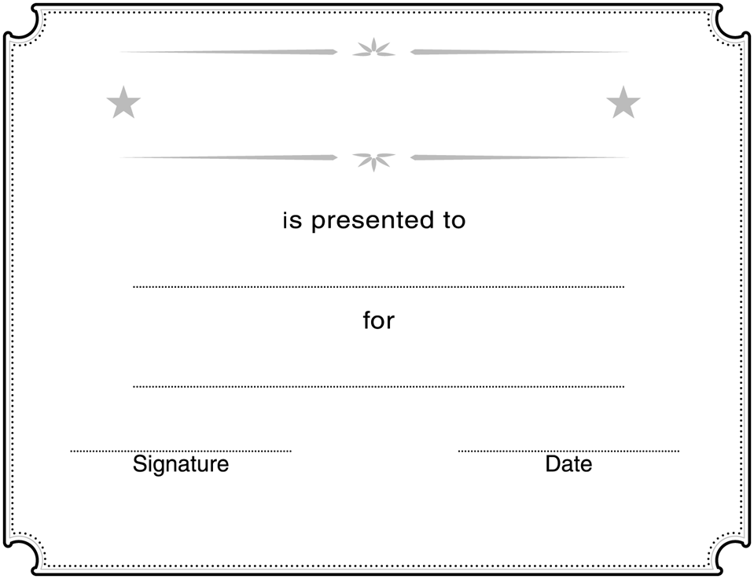

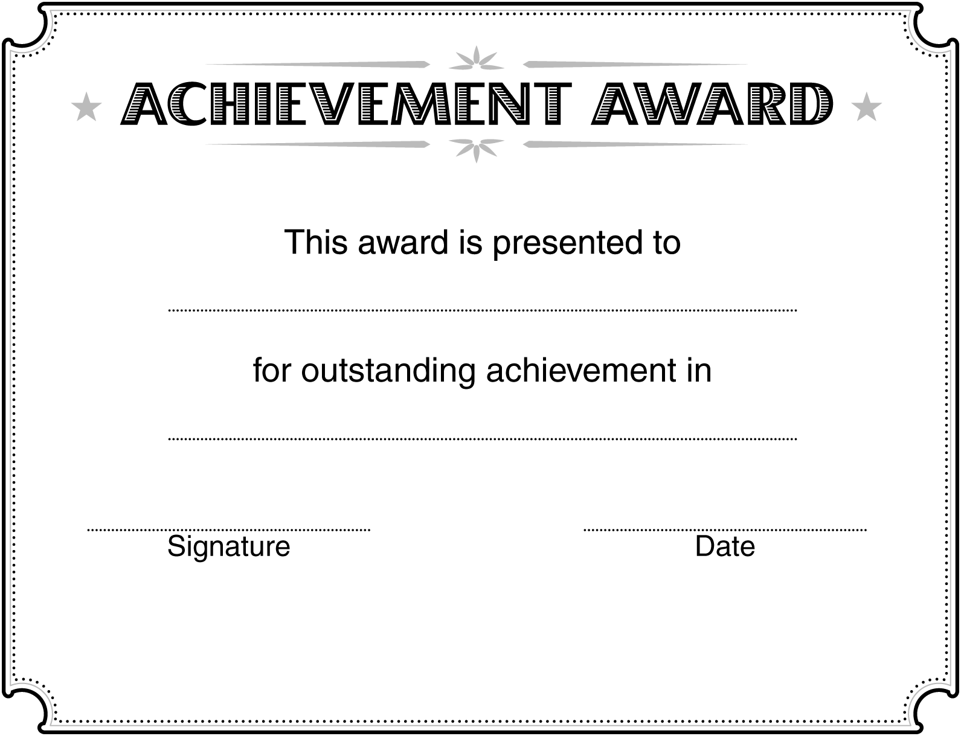

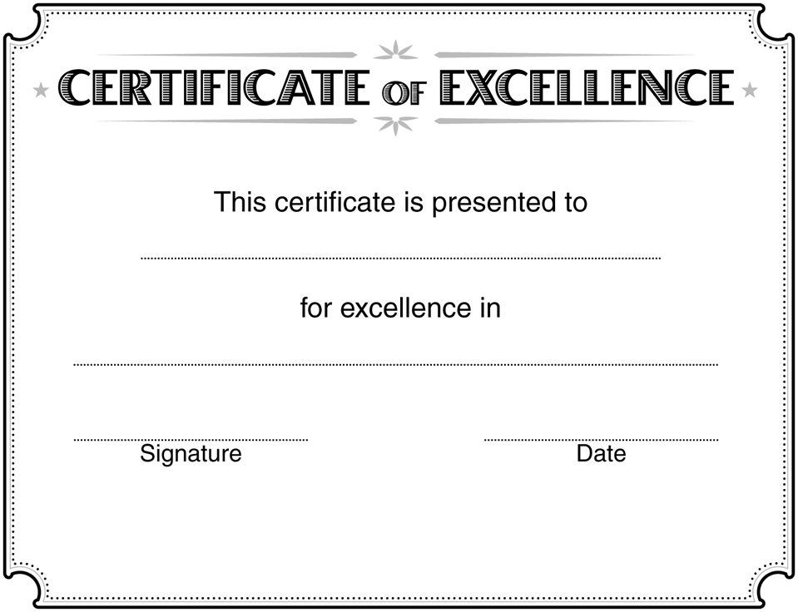

Label Wording for Creating Front and Back Labels for Olymp-i-a Challenge Journals

Front Label- Olymp-i-a Journal- Ashoka Changemaker Schools:
OLYMP-I-A
CHALLENGE
JOURNAL
CHANGEMAKER SCHOOLS

Back Label- Olymp-i-a Journal- Ashoka Changemaker Schools:
The “Olymp-i-a Challenge”
Make peace, green-living, and
health a daily habit. Every idea and
action counts!
http://www.idea4idea.com/

